CORNELL NOTES  MAIN IDEAS\  QUESTIONS | UNIT E, CHAPTER 2.3 -  Materials move across the cell membrane  NOTES:
Cell Membrane  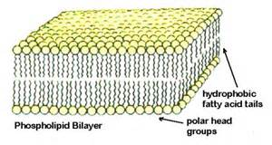 | The outer boundary of the cytoplasm, a layer that controls what enters or leaves the cell.
Permeable  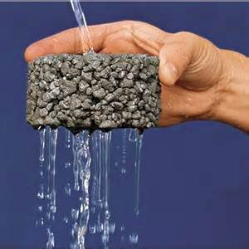 | A substance that materials can flow through.
Semipermeable  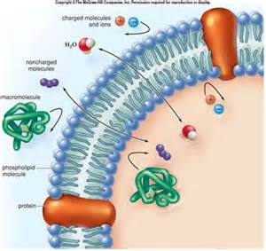 | A substance which only selected materials can flow through.
Diffusion  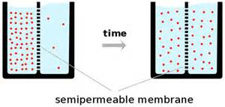 | The tendency of a material to move from an area of high concentration to an area of low concentration.
Osmosis  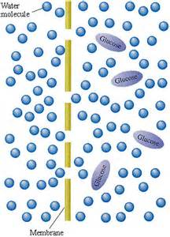 | The movement of water through a cell membrane from an area of high concentration to an area of low concentration.
Equilibrium  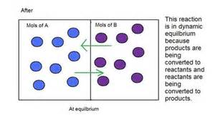 | A state of balance or rest due to equal action from opposing forces.
Active Transport  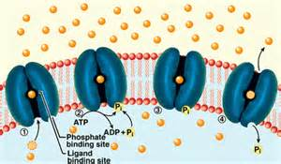 | The process of using energy to move materials through the cell membrane.
Passive transport  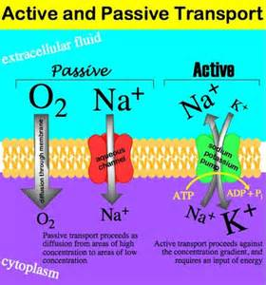 | The movement of materials across the cell membrane without the input of energy.
Hypotonic Solution  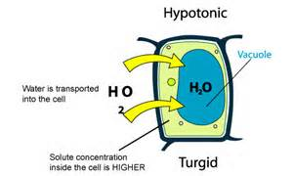 | Any solution with a lower solute concentration than the normal body cells, causing water to flow into the cell by osmosis.
Hypertonic Solution  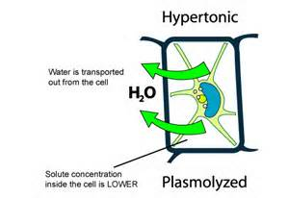 | Any solution with a higher solute concentration than that of a normal body cell, causing water to flow out of the cell by osmosis.
Endocytosis  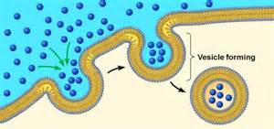 | When materials are too big to move through the cell membrane, the membrane folds in, creating a vesicle, which breaks off and moves into the cell.
Exocytosis  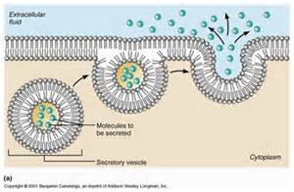 | When materials are too big to move out of the cell membrane, the cell creates a vesicle, which reattaches to the membrane, and opens up to let materials out of the cell.
SUMMARY

